  



Minutes

**SONIA Stakeholder Advisory Group**

21 February 2019

**Location:** Bank of England

## Minute no.

**Minute**

1. **Review of market conditions**

The Bank presented a pack of publically available statistics on the SONIA rate and volumes and SONIA adoption since the reforms were implemented.1

The SONIA rate continued to be stable, with the basis to Bank Rate consistently between 4 to 5 basis points. As anticipated at the Group’s October meeting, the market functioned smoothly over year-end, with the SONIA rate barely moving. The Group discussed that this reflected planning for year-end which has got progressively earlier each year. This meant that if issues arose, they could be resolved in more liquid markets. Although there was some variability in volumes since the previous meeting, the Group were not concerned and felt the benchmark reflected the underlying market well. The Bank noted that the concentration of participants in the underlying market was broadly unchanged since the Bank had taken on publication in April 2018.

Looking forward, the Group highlighted the market’s uncertainty around terms of the UK’s withdrawal from the EU. There was a discussion of the potential impact on the SONIA rate and underlying volumes. One tail risk scenario discussed was where the UK left the EU without a deal, and the European Commission did not grant equivalence to the PRA and FCA. In the unlikely event this were to occur, EU regulated Money Market Funds (MMFs) could be limited as to where they could place sterling deposits; this could impact transaction volumes that ultimately fed into SONIA.

In line with its published policies, the Bank noted it was conducting a periodic review of the current methodology to ensure that it continues to adequately measure the underlying interest. From the Group’s perspective, it continued to do so.

## EU MMF reforms

An overview of the EU MMF Regulation reform was presented to the Group which was followed by a discussion of the likely implications for SONIA.

The reform introduced a framework of requirements for liquidity, diversification, valuation and reporting for MMFs that are established, managed or marketed in the European Union. The regulation would be fully implemented on 21 March 2019. The regulation requires the majority of MMFs to back at least 10% of their liabilities with assets maturing within one day and 30% with assets maturing within a week in order to meet sudden redemption requests and/or manage through adverse market conditions. In practical terms, the majority of MMFs were choosing to meet these requirements with overnight transactions; depending on a fund’s access to markets, this would likely be through placing deposits in the SONIA market or through repo, depending on pricing.

1 The pack is appended to these minutes.

The Group noted this was likely positive for the benchmark, although there was no consensus as to whether there would be an increase in deposits in SONIA as the MMF regulation came into force, or whether most participants had already implemented changes to their activity.

## Evolving uses of SONIA

The Group noted the steady increase in SONIA use in derivatives, both OTC and exchange traded futures. A development since the last meeting was the very significant increase in the issuance of Floating Rate Notes (FRNs) linked to SONIA. It was also noted that those FRNs have begun to trade in the secondary market.

Regarding further uses of SONIA in the market, these remained focused on the use of SONIA as a compounded rate; members were not aware of proposals to use SONIA as a single observation.

## Published documentation

The Bank sought the members’ views on the publicly available documentation on SONIA. The feedback was positive.

## Future discussion topics

In the light of the ongoing uncertainty on terms of the UK’s withdrawal from the EU, the Chair noted it may be appropriate for the Group meet before the next meeting in the autumn.

He also encouraged Members to propose topics for future discussions.

## Attendees:

Chair Richard Moore (Independent member of SONIA Oversight Committee)

CurveGlobal Ian Murphy

Goldman Sachs Chirag Dave

HSBC James Murphy Insight Investment Robert Gall ISDA Jonathan Martin

JP Morgan AM Olivia Maguire

LCH Philip Whitehurst

LGIM John Wherton

Lloyds Bank Graham Whitehair

Mizuho Rob Thurlow RBC Capital Markets Anthony Tobin Société Generalé Romain Sinclair TP ICAP Philip Chilvers

Bank of England Will Parry

Joanna McLafferty

## Apologies:

Julia Black (Independent member of SONIA Oversight Committee) Rhys Phillips Bank of England

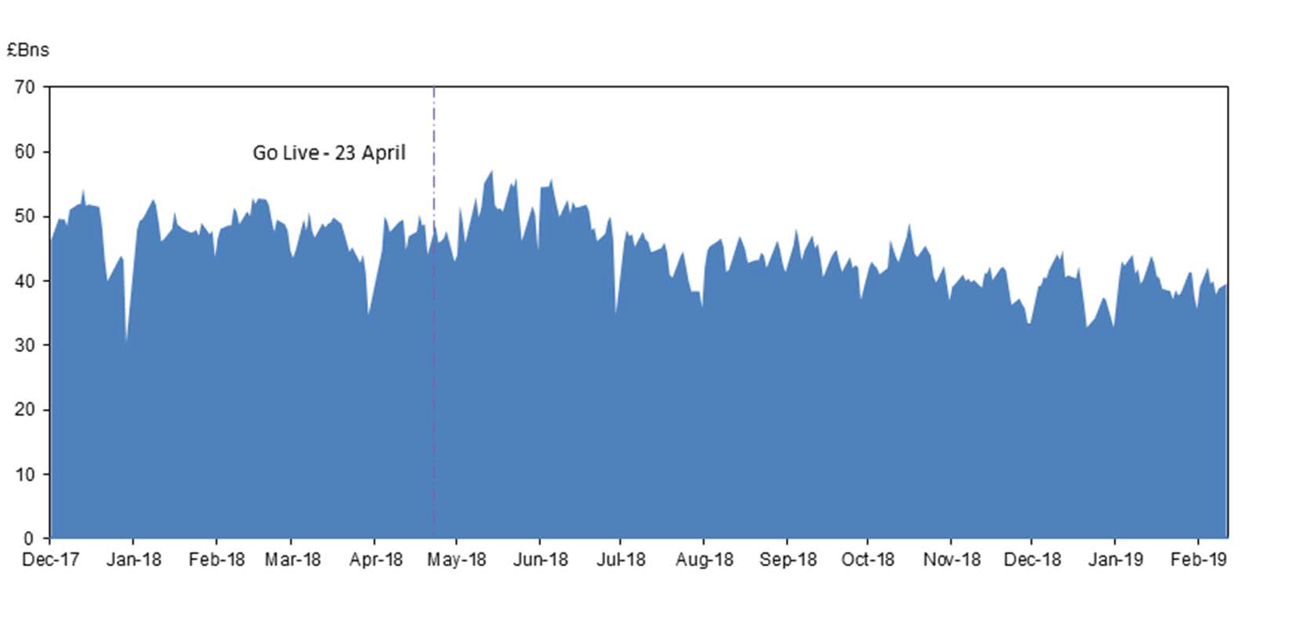

Chart 1: SONIA volumes

*Source: Bank of England*

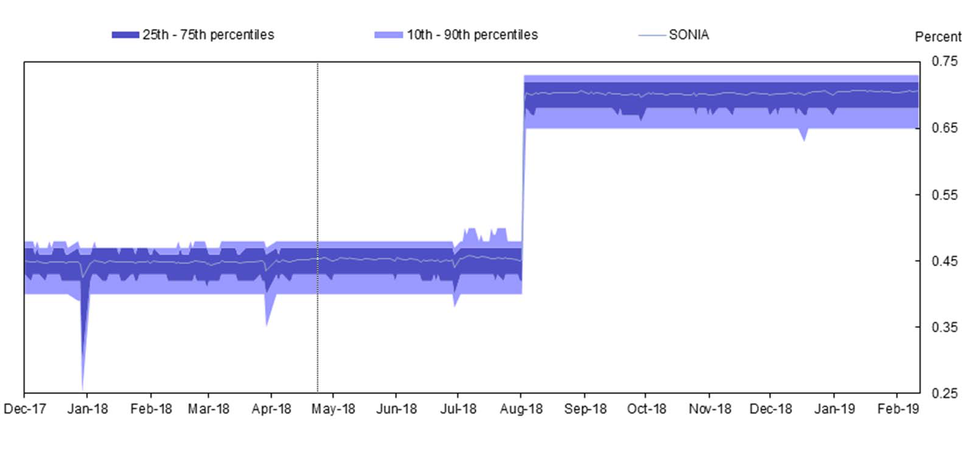

*Source: Bank of England*

**SONIA Stakeholder Advisory Group**

February 2019

# Published SONIA statistics

Chart 2: SONIA rates and percentiles

*Volumes, rates and percentiles before 23 April 2018 are calculated using SMMD data. This can be found on the Banks website as the data presented in the ‘SONIA key features and policies document’ under the reformed methodology.*

Usage of SONIA

*Source: ICE Futures, Curve Global and CME Group*

*\* Lots traded multiplied by nominal lot size*

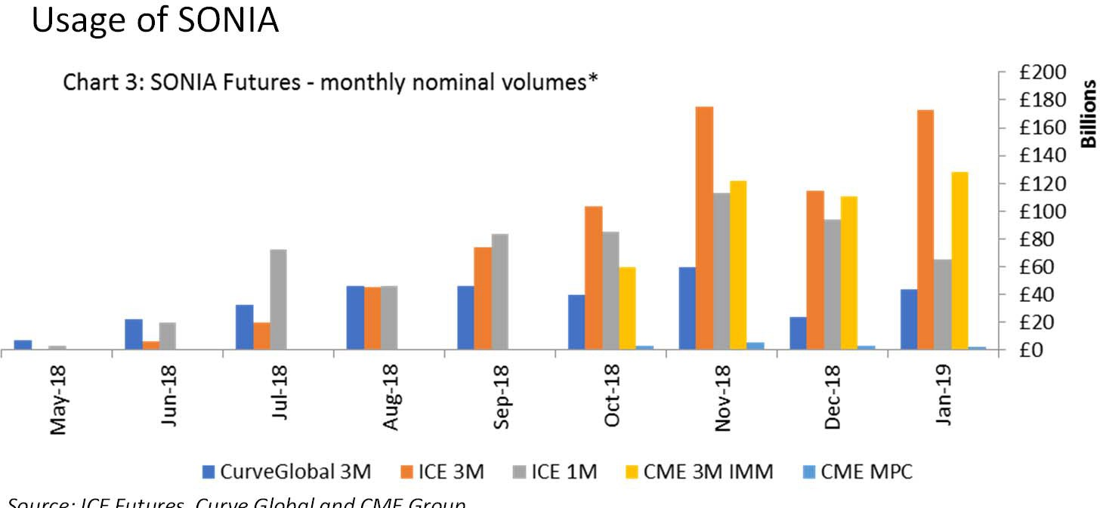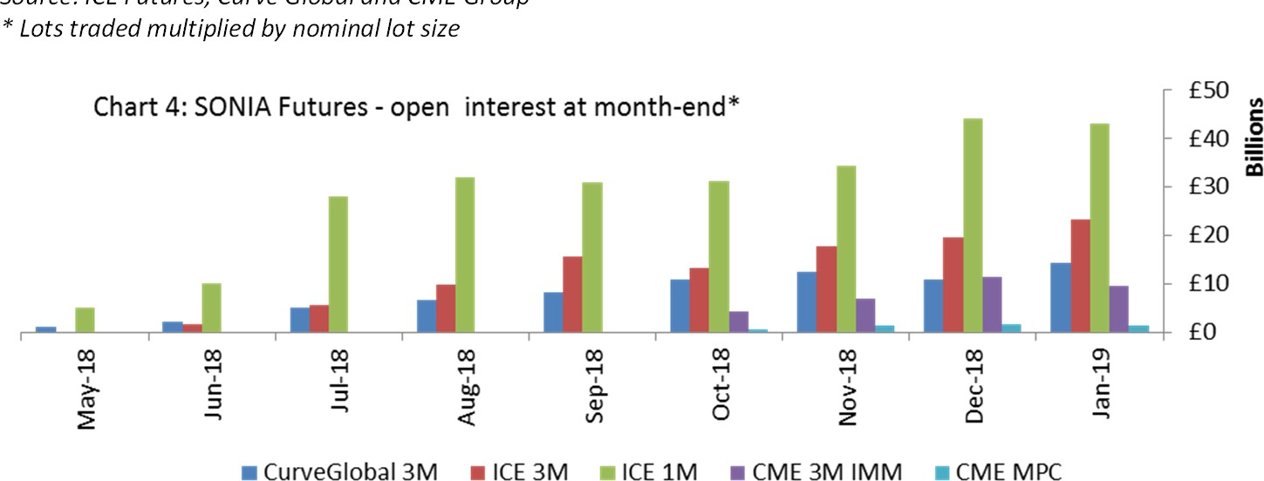

*Source: ICE Futures, Curve Global and CME Group*

*\* Lots open multiplied by nominal lot size*

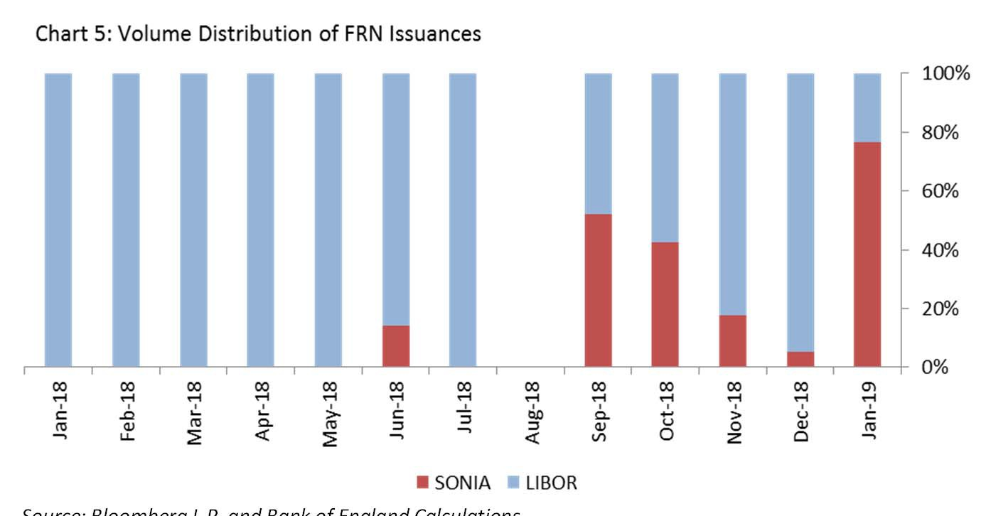

*Source: Bloomberg L.P. and Bank of England Calculations*